**Creating a procedure or function in mysql**

Always keep in mind that the syntax of the procedures, functions and triggers in MYSQL is not same as Oracle. Obviously almost similar but you have to carefully write these. You may have Google search to find the dissimilarities.

It can be done in two ways:

Method 1:

Left click on the database (not the table!)

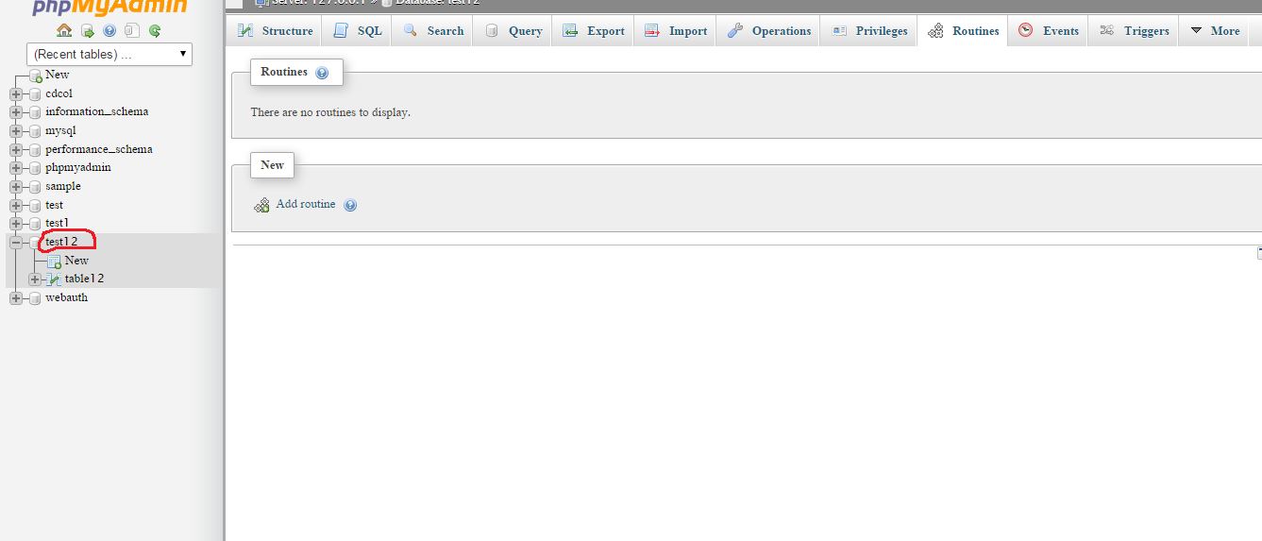

Left click on Routines tab and then Add Routine

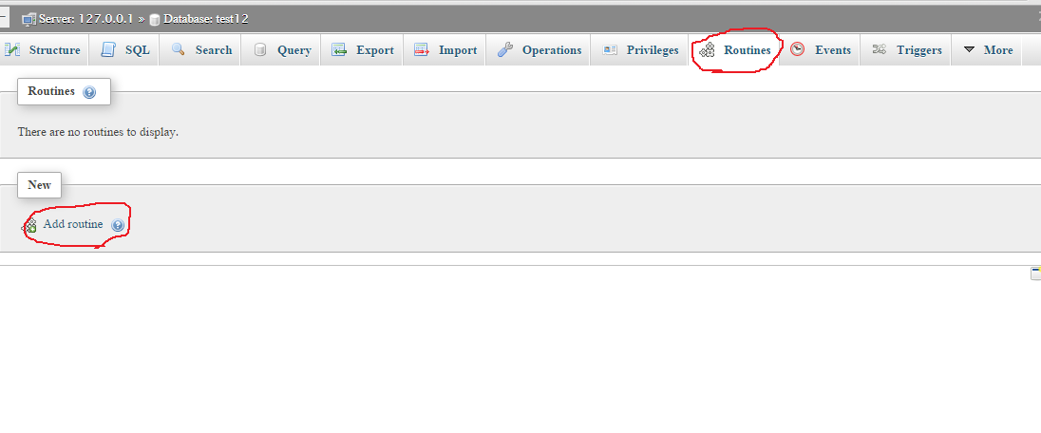

You will find a pop-up window. Define all the necessary fields. Here is an example

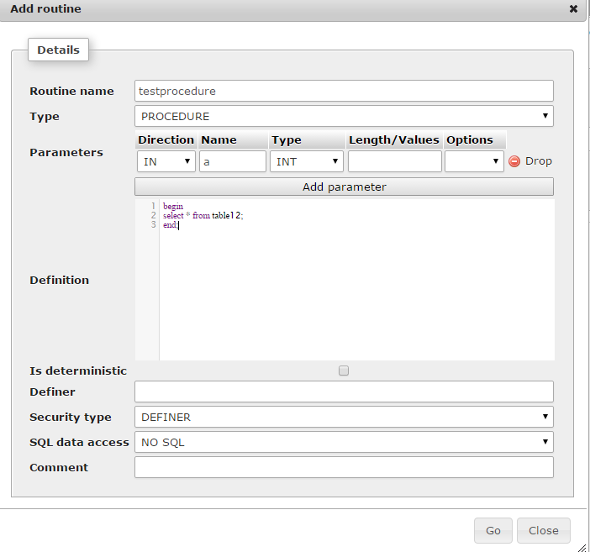

Your procedure will be created and will be found under Procedures of the database name (You have to refresh the browser and click on procedures to see it)

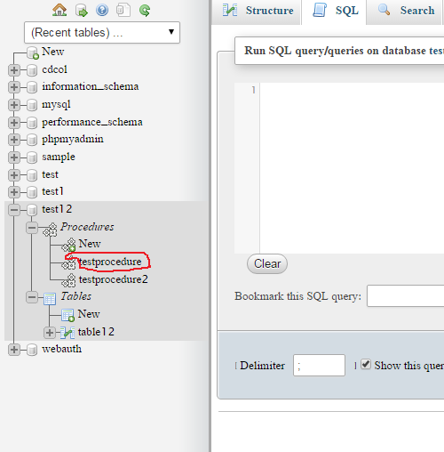

Method 2:

Left click on the database (not the table !) as shown in Method 1.

Left click on SQL tab. Then write the definition of the procedure or function there. And click the “Go” Button.

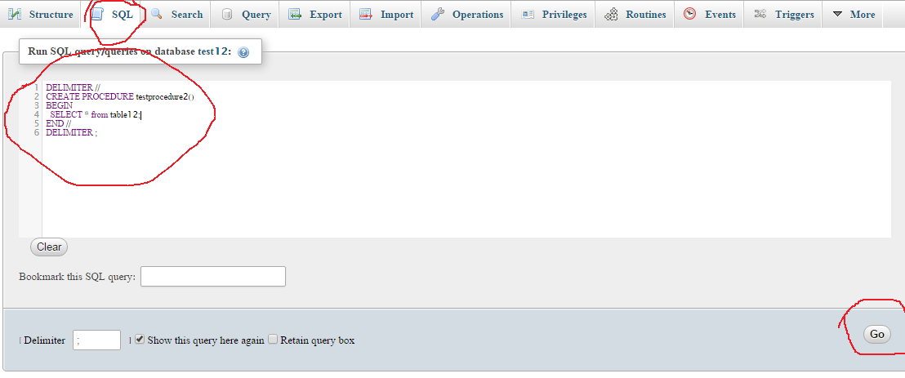

If you successfully do it then you will find the procedure created. Your procedure will be created and will be found under Procedures of the database name(You have to refresh the browser and click on procedures to see it)

